Name:Manishkumar Bhosiwad

What is Git?
So, what is Git in a nutshell? This is an important section to absorb, because if you understand what Git is and the fundamentals of how it works, then using Git effectively will probably be much easier for you. As you learn Git, try to clear your mind of the things you may know about other VCSs, such as CVS, Subversion or Perforce — doing so will help you avoid subtle confusion when using the tool. Even though Git’s user interface is fairly similar to these other VCSs, Git stores and thinks about information in a very different way, and understanding these differences will help you avoid becoming confused while using it.

- Git lets developers see the entire timeline of their changes, decisions, andprogression of any project in one place. From the moment they access the history of a project, the developer has all the context they need to understand it and start contributing.
- Developers work in every time zone. With a DVCS like Git, collaboration can happen any time while maintaining source code integrity. Using branches, developers can safely propose changes to production code.
- Businesses using Git can break down communication barriers between teams and keep them focused on doing their best work. Plus, Git makes it possible to align experts across a business to collaborate on major projects.

Basic Git commands
To use Git, developers use specific commands to copy, create, change, and combine code. These commands can be executed directly from the command line or by using an application like GitHub Desktop. Here are some common commands for using Git:
- git init initializes a brand new Git repository and begins tracking an existing directory. It adds a hidden subfolder within the existing directory that houses the internal data structure required for version control.

- git clone creates a local copy of a project that already exists remotely. The clone includes all the project's files, history, and branches.

- git add stages a change. Git tracks changes to a developer's codebase, but it's necessary to stage and take a snapshot of the changes to include them in the project's history. This command performs staging, the first part of that two-step process. Any changes that are staged will become a part of the next snapshot and a part of the project's history. Staging and committing separately gives developers complete control over the history of their project without changing how they code and work.

- git commit saves the snapshot to the project history and completes the change-tracking process. In short, a commit functions like taking a photo. Anything that's been staged with git add will become a part of the snapshot with git commit.

- git status shows the status of changes as untracked, modified, or staged.

- git branch shows the branches being worked on locally.

- git merge merges lines of development together. This command is typically used to combine changes made on two distinct branches. For example, a developer would merge when they want to combine changes from a feature branch into the main branch for deployment.

- git pull updates the local line of development with updates from its remote counterpart. Developers use this command if a teammate has made commits to a branch on a remote, and they would like to reflect those changes in their local environment.

- git push updates the remote repository with any commits made locally to a branch.

Manage projects with Repositories
- Clonea project to work on a local copy
- Control and track changes with Staging and Committing
- Branch and Merge to allow for work on different parts and versions of a project
- Pull the latest version of the project to a local copy
- Push local updates to the main projec
1. First step is create a github acoount

2.download the file of as required git bash file windows or other operating system.

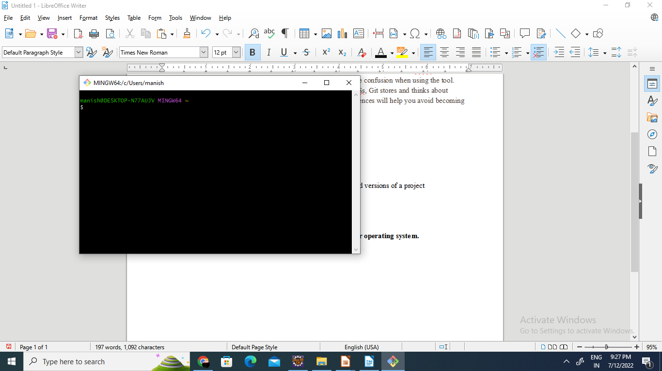
3.install the git bash file and run

4. git bash promopt check the version of git bash
git --version

5. Change the current working directory to your local repository.
Cd Document

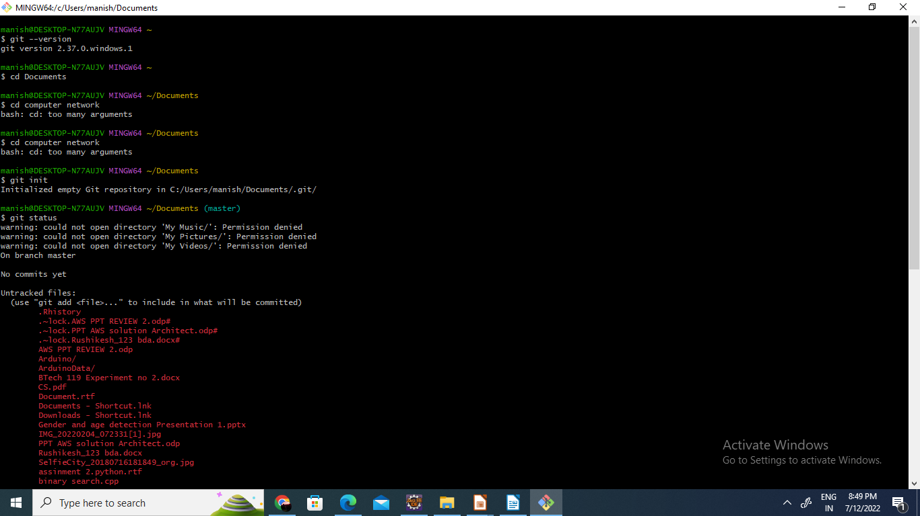

Stage the file for commit to your local repository.
-git add
---Adds the file to your local repository and stages it for commit
-git commit -m "Add existing file"

-# Commits the tracked changes and prepares them to be pushed to a remote repository. To remove this commit and modify the file, use 'git reset --soft HEAD~1' and commit and add the file again.
